**Introduction**

A **resort** ([North American English](https://en.wikipedia.org/wiki/North_American_English)) is a self-contained commercial establishment that tries to provide most of a [vacationer](https://en.wikipedia.org/wiki/Vacation)'s wants, such as food, drink, [lodging](https://en.wikipedia.org/wiki/Lodging), [sports](https://en.wikipedia.org/wiki/Sport), [entertainment](https://en.wikipedia.org/wiki/Entertainment), and [shopping](https://en.wikipedia.org/wiki/Shopping), on the premises.

One of the most famous resorts in NorthWest Montana is Big Mountain Resort. The resort originally opened in 1947 and is visited by ~350,000 people every year.

Offers :-

* Views of Glacier National Park and Flathead National Forest.
* Annual Snowfall of 333inches
* 3000 acres of skier and rider accessible terrain.
* Access to 105 named trails and vast bowl and tree skiing.

Facilities :-

* 11 Lifts
* 2 T-Bars
* 1 Magic Carpet

Features:-

* Hellfire is the longest run of 3.3 miles in length.
* Base elevation 4464 ft
* Top 6817ft with vertical drop of 2353ft.
* Located in Montana
* Visited by 350,000 people approx.

Big Mountain Resort had recently installed an additional chair lift to help increase the distribution of visitors across the mountain. This additional chair increases their operating cost by $1540000 this season.

In this project I try to find out ways in which Big mountain resorts can cope up with the increased operating cost and also make some profit by analyzing a resort data csv file provided by the database manager and US State population data from Wikipedia.

**Assumptions**

All other resorts are accurately setting prices based on how much people value certain facilities. Essentially this assumes prices are set by a free market.

**About the Model**

Three different regression models were used before selecting the final model.

* DummyRegressor
* Linear Regressor
* RandomForestRegressor

After the data cleaning, EDA and preprocessing. Model that is used to predict the Ticket price of Big Mountain Resort is RandomForest Regressor..

Below are the results of HyperParameter Searching using GridSearchCV.



**Top Features**

Below were the top features in the decreasing order of their importance. Out of which top 4 were common with LinearRegression Model.

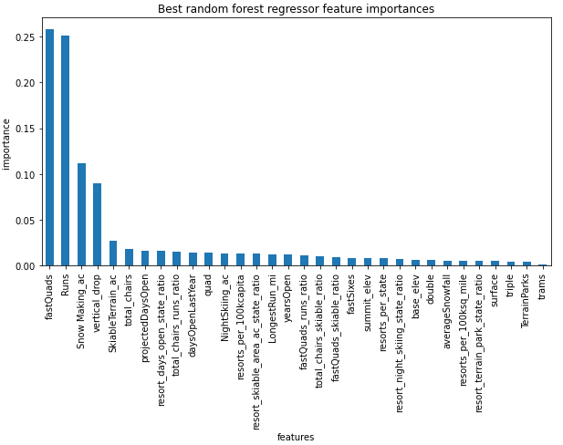

**Data Quantity Assessment**

The figure below shows that we have plenty of data. There's an initial rapid improvement in model scores as one would expect, but it's essentially levelled off by around a sample size of 40-50.

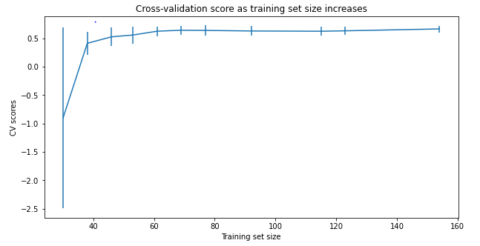

**Recommendation for Big Mountain Resorts**

1. As per the model Big Mountain Resort Weekend Price should be $95.19 whereas the actual price is $81. The Expected mean absolute error is $10.34 which means there is still room for an increase.

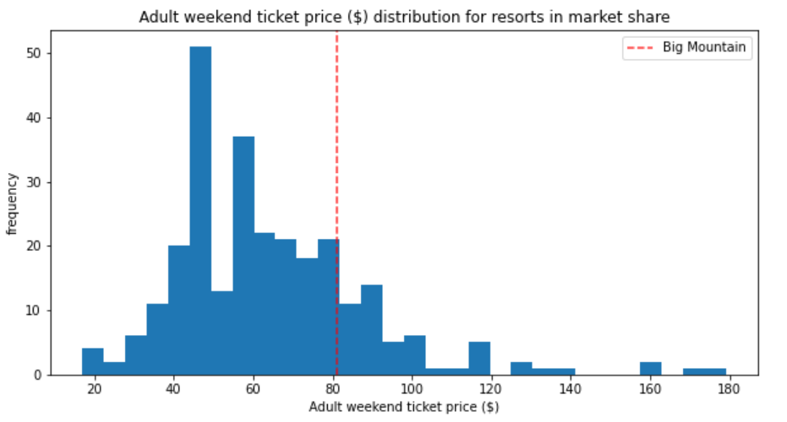

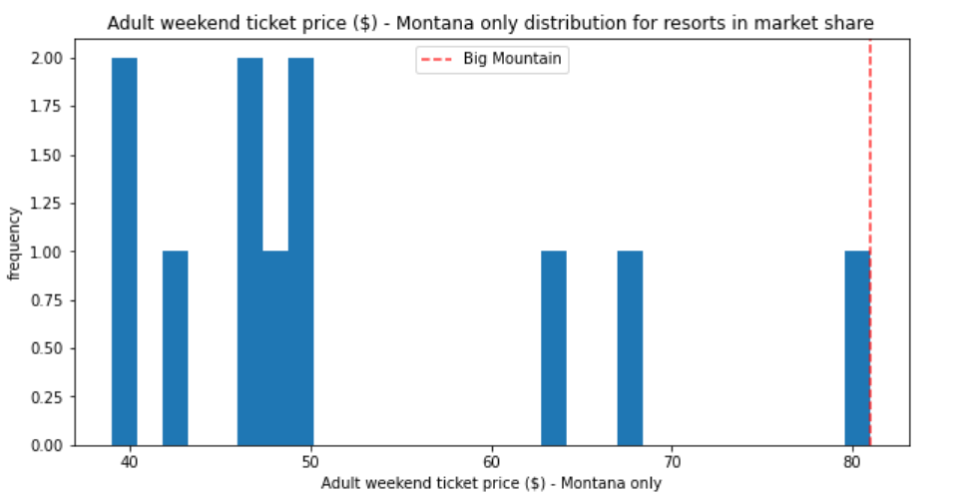

1. Permanently closing down up to 10 of the least used runs. This doesn't impact any other resort statistics.

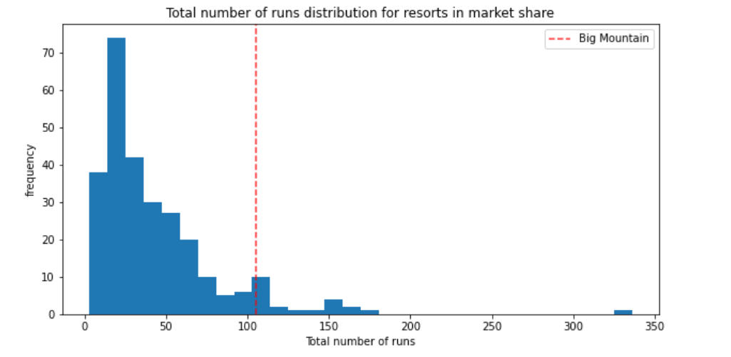

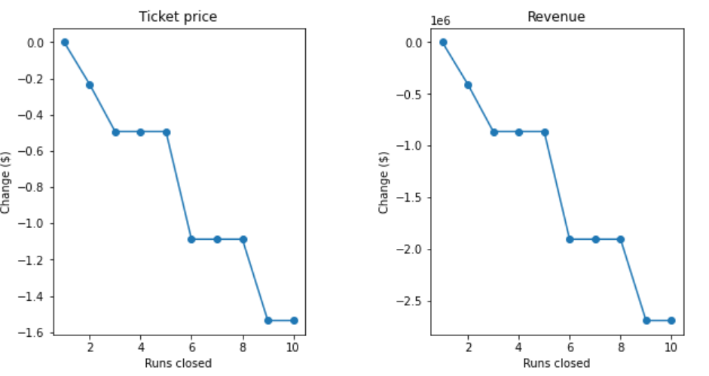

The model says closing one run makes no difference. Closing 2 and 3 successively reduces support for ticket price and so revenue. If Big Mountain closes down 3 runs, it seems they may as well close down 4 or 5 as there's no further loss in ticket price. Increasing the closures down to 6 or more leads to a large drop.

1. Increase the vertical drop by adding a run to a point 150 feet lower down but requiring the installation of an additional chair lift to bring skiers back up, without additional snow making coverage

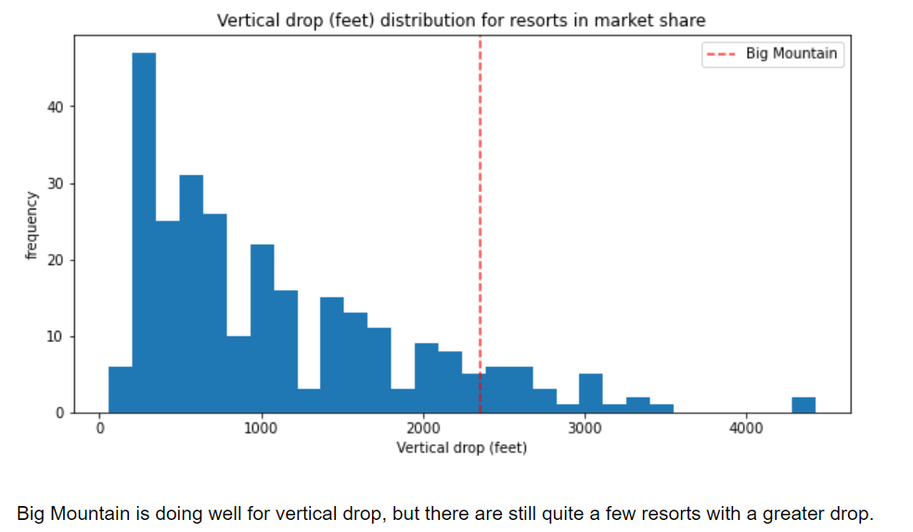

The scenario increases the price by $1.99 and over the season, this could be expected to amount to $3474638 with expected visitors of 350000.

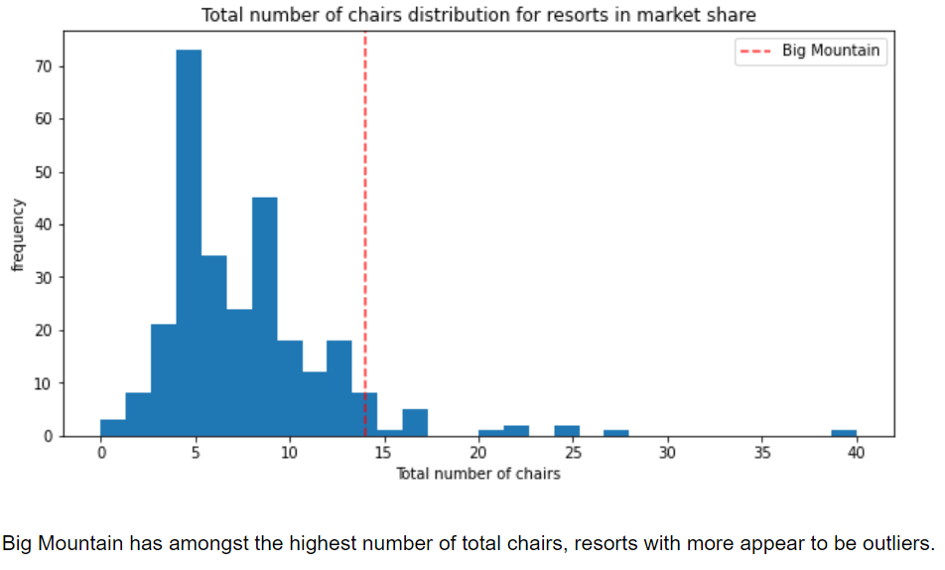

1. Same as number 3, but adding 2 acres of snow making cover

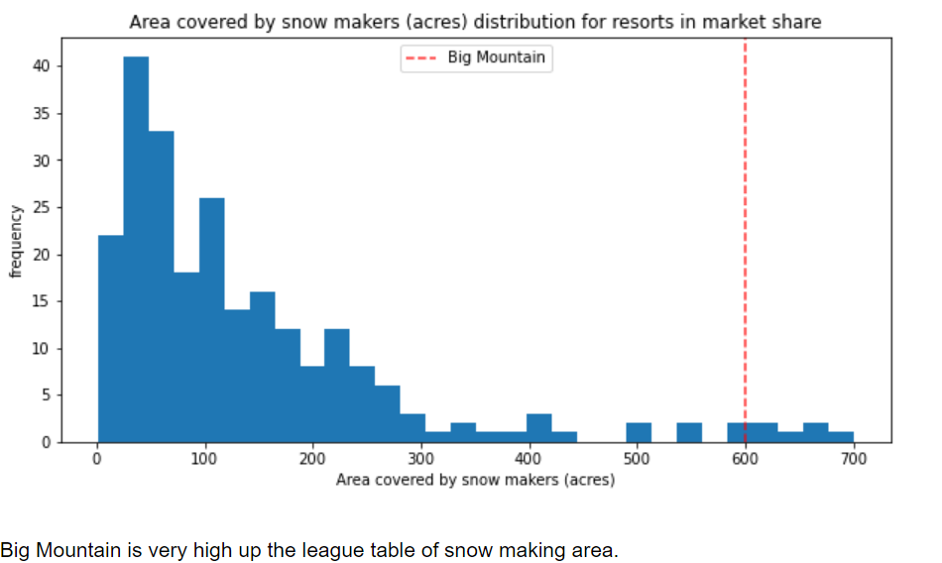

1. Increase the longest run by 0.2 mile to boast 3.5 miles length, requiring an additional snow making coverage of 4 acres

